Odd/Even/Compact* Semester (year)


BINUS UNIVERSITY

BINUS INTERNATIONAL


Assignment Cover Letter

(Individual/Group* Work)

Student Information: Surname Given Names Student ID Number
1. Stanlly Stanlly 2301923533
2.
3.

4.
5.

Course Code : COMP6510 Course Name : Programming Languages

Class : L2BC Name of Lecturer(s) : Jude Joseph Lamug Martinez

Major : Computer Science

Title of Assignment : Term Project
(if any)

Type of Assignment : Term Project

Submission Pattern

Due Date : June 08 2020 Submission Date :

The assignment should meet the below requirements.

- Assignment (hard copy) is required to be submitted on clean paper, and (soft copy) as per lecturer’s instructions.

- Soft copy assignment also requires the signed (hardcopy) submission of this form, which automatically validates the softcopy submission.
- The above information is complete and legible.
- Compiled pages are firmly stapled.
- Assignment has been copied (soft copy and hard copy) for each student ahead of the submission.

Plagiarism/Cheating
BiNus International seriously regards all forms of plagiarism, cheating and collusion as academic offenses which may result in severe penalties, including loss/drop of marks, course/class discontinuity and other possible penalties executed by the university. Please refer to the related course syllabus for further information.

Declaration of Originality

By signing this assignment, I/we* understand, accept and consent to BiNus International terms and policy on plagiarism. Herewith I/we* declare that the work contained in this assignment is my/our* own work and has not been submitted for the use of assessment in another course or class, except where this has been notified and accepted in advance.

Signature of Student: (Name of Student)

1.Stanlly

Contents

- Project Specifications
- Proposal
- UML Diagrams
- How the program works
- Final Product
- Resources

Project Specifications

- Use of primitive data
- Use of instance variables and objects
- Use of imported classes
- Use of custom-built classes and methods
- Use of Java Collection
- Use of exception handling
- Use of inheritance, polymorphism and interfaces
- Detailed Documentation Commenting
- Detailed Commenting Methods
- Detailed Code Commenting

Proposal

My project is a bus booking system. It is planned to be used by administrators at a bus station. This helps them keep track of specific bus seats that have been rented out by commuters and helps automate the sorting process.

The program also has a bus scheduler in order to help keep track of where each bus is headed as well as when. It will also have functions to change the schedules when necessary.

The data will then be saved in a file in order for business to continue as usual.

UML Diagram

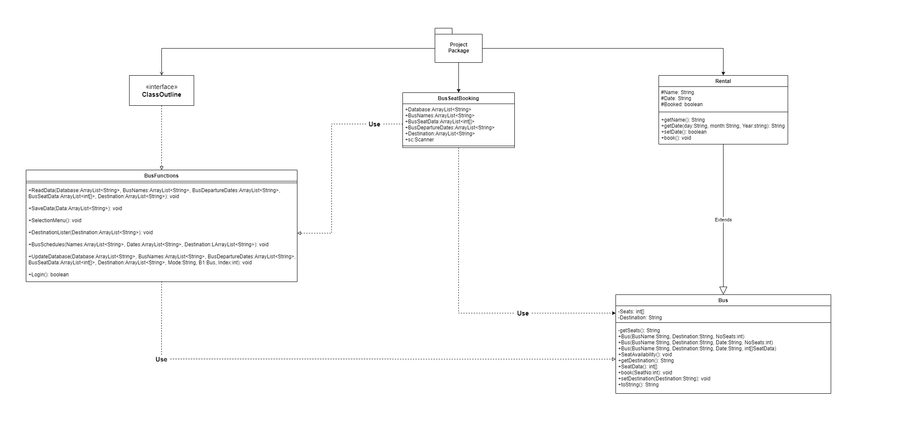
The program is composed of 3 java files.

The first (BusFunctions) contains an interface (outline) and implements its functions.

The second (Bus) contains a super class (rental) which is extended in order to create the Bus class.

BusSeatBooking then uses the 2 java files for its functions.

How does it works?

The Functions:
Let’s start with the functions java file. All non-class functions used in this project is contained in BusFunctions.java. This Java file contains an interface that declares all functions to be implemented and implements said functions.

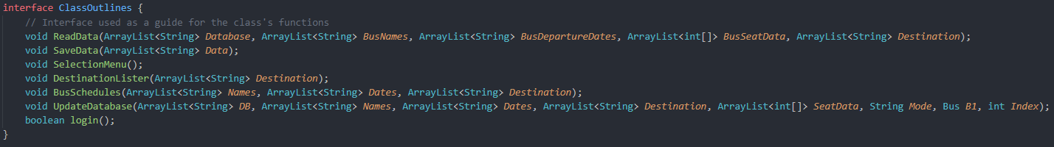
Let’s go over the functions from the top.

ReadData and SaveData: This file handles the file reading portion of the program. The program allows saving data into a txt file. This txt file is loaded every time the program starts and saved when the program ends. These 2 functions handle this aspect of the program!

SelectionMenu, DestinationLister and BusSchedules: These functions handle the menu aspect of the program. The menus are printed in text and formatted to look as clean as possible.

UpdateDatabase: This function handles updating the database as the user is changing the data in the program. This ensures that every single change that is done is recorded and saved into the txt “save” file every time the user exits.

Login: The function that handles the login menu. It checks the user’s credentials. If they get the check wrong 3 times, they are kicked out of the program.

The login function uses base64 encryption method in order to keep password data safe. When the user tries to log in, the function checks the entered password and the saved credentials to see if they match up.

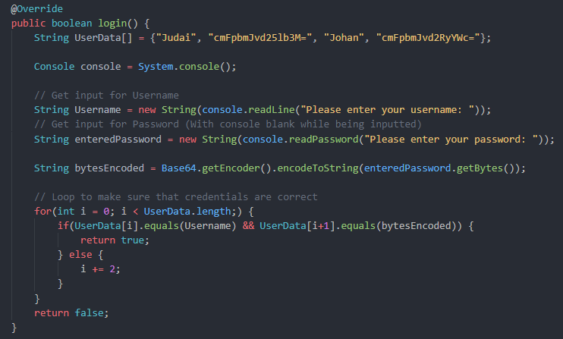

The Classes:

This program contains 2 main classes whose variables are used in the program.
The Rental parent class and the Bus child class.

The Rental Class: This class handles the generic variables and functions. It contains variables such as “Name”, “Date” and a boolean “booked”. The program was planned to use different methods of transportation but only uses the child class Bus in the final project.

The Bus Class: The main class of the project. This class contains every function necessary to be used in the program. It has 3 different constructors to be used in different situations as well as a plethora of functions to be used for the program.

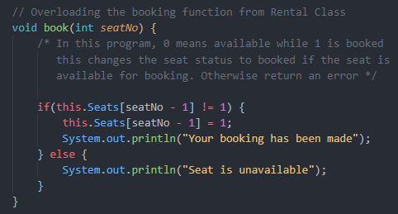
The code above is an overloaded function. The Bus Class is overloading the book function present in the Rental class. This is necessary as the class has multiple seats to be booked rather than having the entire vehicle labeled as booked.

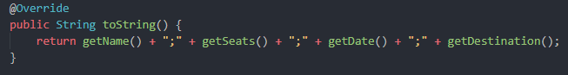
The overrided function “toString” has been modified to be used for exporting data. This is used in conjunction to the “UpdateDatabase” function from BusFunctions.java in order to export the data to the “save file”
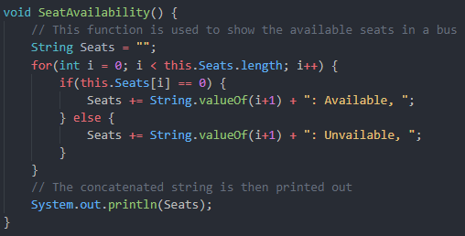
This function handles the printing of the availability of seats in a given bus. This will print text in the format:
SeatNumber: Availability (Available or Unavailable)

The Driver Class:

The driver class is mainly just a big while loop with a few checks as well as exception handling. To save time, I will mainly be showing the main parts of the program.
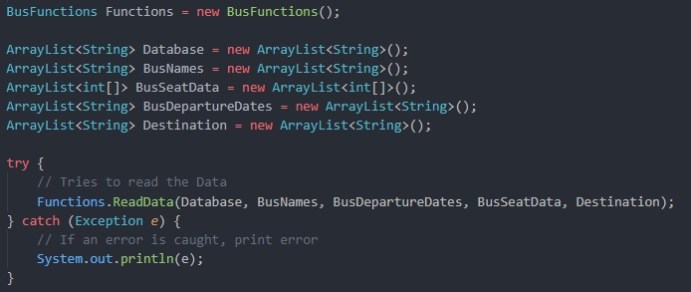
In the code above, 5 ArrayLists are initialized, these lists are the databases that are going to store our different forms of data used in the program.

A try and catch is implemented in order to catch any errors from reading data.

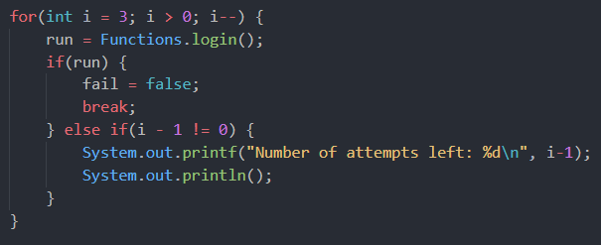
The code above is the loop used to check the login data. When the user has entered their credentials correctly, the boolean “run” will be set to true. A simple else if is used in order to break the loop as soon as the user gets their password right. Otherwise, print a statement of how many attempts are left and restart the login process.

When all 3 attempts are used up, the user is kicked out of the program.

Outside of these main functions, the rest of the program is basic switch cases and if else statements

The Final Program:

Login Process:
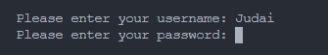
Main Menu:
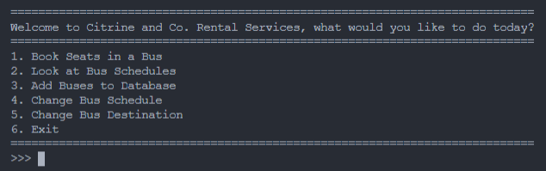
Option 1:
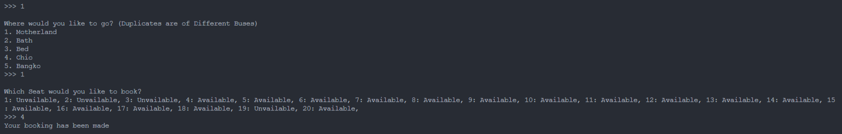
Option 2:
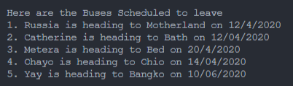

Option 3:
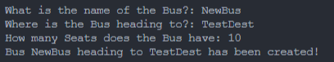

Option 4:
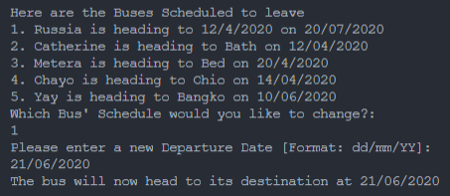

Options 5:

